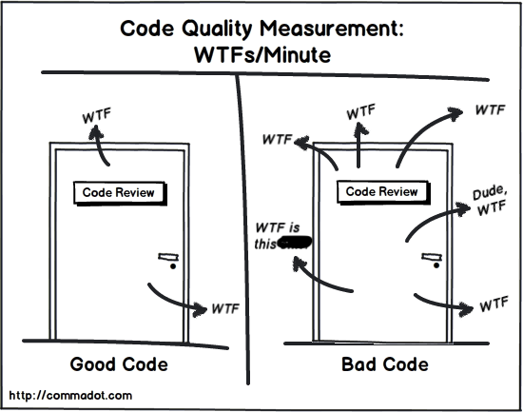

**Name: Abdel Rahman Adel**

**Task: Clean code concepts**

### 1- *Create Meaningful Names*

**#Clean code#----->** **A name should tell you why it exists**

**#Bad code#---->use comments to explain why a variable is used**

### 2-*Avoid Noise Words*

**#Clean code#----->do not offer any additional information about the** variable

**#Bad code#---->If your class is named UserInfo**

### 3-*Use Pronounceable Names*

### 4-*Use Searchable Names*

### #clean code#----->Avoid using magic numbers in your code.

### #Bad code#----> use single-letter names for constants

### 5-*Keep the function Small*

**#clean code#------>Functions should be small. They should rarely be 20 lines long.**

**#Bad code#------>** **The longer a function gets, it is more likely it is to do multiple things and have side effects.**

### 6-*Make Sure That the function Just Do One Thing*

### 7-*Encapsulate Conditionals in Functions*

### 8-*Do not leave code in comments*

# **9-** ***Keep method parameter count to a minimum***

# **10- *Declare variable at the place of use***

**#Clean code#-------->** **when variables are declared at the place where they are actually being used**

**#Bad code#------>** **to declare all the variables at the top. These types of code are hard to be read. I prefer it. That way you won’t have to scroll back and forth to understand your code.**

# **11- *Avoid using confusing magic numbers***

# **12-** ***Minimise extensive nested conditions***

**#Clean code#------->** **try to simplify them**

**#Bad code#------>Multiple nested conditions make it hard to read your code. Always. Above code can be simplified**

# **13- *Avoid code duplication***

# **14- *Make necessary comments***